**Civic Platform 8.0 Browser Support Policy**  
Accela strives to provide the best and safest government software in the market.  In order to do this effectively, we are dependent on the frequent and important advances of the modern web browser. Over the last several years, Accela has supported the current and previous major releases of Internet Explorer. However Microsoft has published a new browser support policy that states the following:  
  
*“Beginning January 12, 2016, only the most current version of Internet Explorer available for a supported operating system will receive technical support and security updates. Please visit the Internet Explorer Support Lifecycle Policy FAQ here*[*http://support.microsoft.com/gp/Microsoft-Internet-Explorer*](http://support.microsoft.ccivic-platform-8-0-browser-support-policyom/gp/Microsoft-Internet-Explorer)*for list of supported operating systems and browser combinations.”*  
  
With the new policy, Microsoft will stop issuing security patches for Internet Explorer 10.  We rely on modern browsers to consistently improve security, performance, and compliance with current web standards. For this reason we will no longer support Internet Explorer 10 in our next major release, Civic Platform 8.0 coming out fall 2015.    
  
Users that are not running one of the supported browsers may experience issues with some features or pages.  In order to receive the best user experience we recommend your organization move to Internet Explorer 11.  If your organization depends on older versions of Internet Explorer for other purposes, you may want to consider a dual browser strategy.  The Civic Platform 8.0 release will support the following web browsers.  Please review the [limitations](https://accela.force.com/success/articles/Knowledge/Civic-Platform-8-0-Browser-Support-Policy#LIMITATIONS)before moving to a new browser/version.

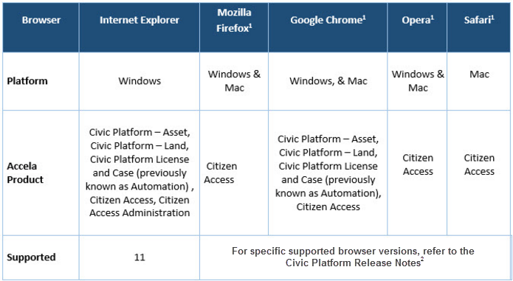

1Supported versions of this Web browser auto-update without any user intervention.   
2Civic Platform 8.0 Release Notes are available [here](https://accela.force.com/success/06932000001o34K?retUrl=%2Fsuccess%2F_ui%2Fcore%2Fchatter%2Ffiles%2FFileTabPage).  
  
We depend on these browsers to provide continued improvements to security, speed, and new functionality.  We are committed to provide our customers with safe, modern and user friendly solutions.  A current browser is required to meet these needs.  
  
**LIMITATIONS**:  Silverlight is used in some areas of the v360 and 8.0 user interface.  Google Chrome may not be ideal for users that use the following features/functions:

* GIS/Maps in v360 User interface and Citizen Access
* Record Type Administration and Data Manager
* Citizen Access Administration
* Workflow Designer
* International Languages
* ActiveX Controls
* Misc. Administrator Tools

To effectively use Chrome, agency users must enable pop-up windows.

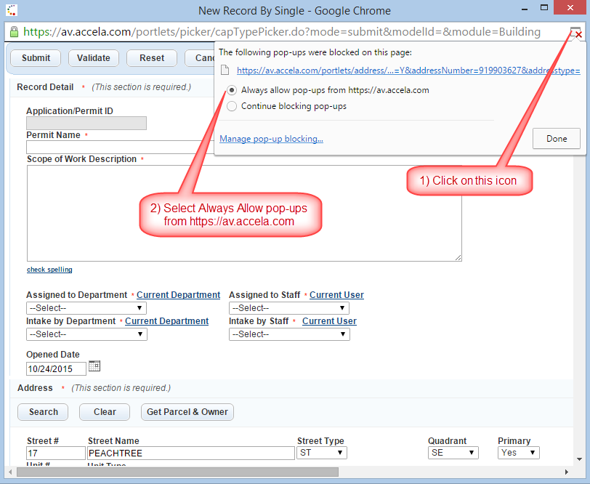

**Note**: The Silverlight document upload function can be disabled in Citizen Access following the steps found in this article, [Upload Documents in Chrome](https://accela.force.com/success/articles/Knowledge/ACA-Problem--cannot-upload-document-using-Google-Chrome?popup=true). Silverlight has been removed from the document functionality in the back office.  
  
**SSL Certificates and Web Security**  
The Accela Civic Plaform requires secure HTTPS protocol for all communications. Secure HTTPS protocol protects your agency’s data by requiring all internal agency users to access Accela Automation using SSL communication with robust data encryption.  
  
To enable security for transactions that you conduct with Accela Automation, an administrator must configure secure services. You can easily identify secure web services, by verifying that they display “https” instead of “http” at the beginning of the URL. If you are a self-hosted customer and would like more information on how to install SSL Certificates for the Accela Civic Platform, please see the [**On Demand Webinar: Installing SSL Certificates for the Accela Civic Platform**](https://accela.force.com/success/articles/Webinar/On-Demand-Webinar-Installing-SSL-Certificates-for-the-Accela-Civic-Platform?popup=true).  
  
The services that require security measures within Accela Automation include payment processors such as VeriSign, external address, parcel, and owner (APO) data, electronic document management systems (EDMS), and Lightweight Directory Access Protocols (LDAPs).